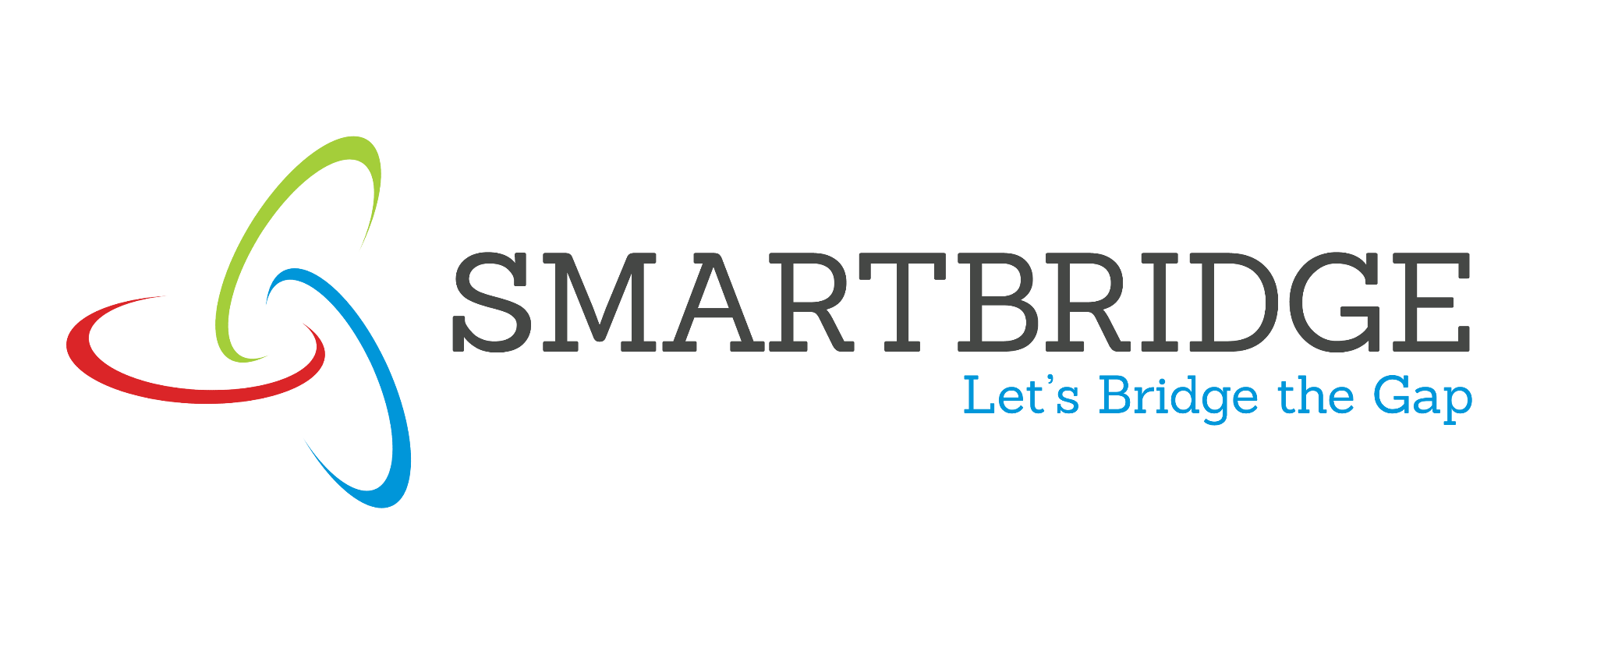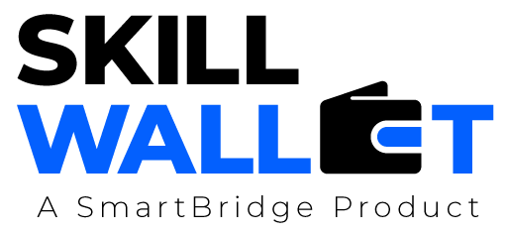
Proposed Solution

Date | 3rd July 2026
Team ID | xxxxx
Project Title | Rising  Water
Maximum Marks | 5 Marks

Project Proposal (Proposed Solution) report

Project Overview
Objective | The primary objective is to develop a Machine Learning-based Flood Prediction System that accurately predicts flood risk using rainfall and weather data. The system aims to provide early warnings to improve disaster preparedness and reduce the impact of floods..
Scope | The project includes collecting flood-related datasets, preprocessing data, analyzing weather patterns, training multiple Machine Learning models, selecting the best-performing model (XGBoost), and deploying the solution through a Flask web application on IBM Cloud.
Problem Statement
Description | Traditional flood prediction methods are often slow and less accurate, making it difficult for authorities and the public to respond quickly. There is a need for an intelligent system that predicts flood risk using historical weather and rainfall data.
Impact | An accurate flood prediction system helps reduce the loss of life and property by providing early warnings, supporting disaster management, and enabling timely preventive actions.
Proposed Solution
Approach | Develop a Machine Learning model using Python and XGBoost to analyze rainfall and meteorological data. The trained model is integrated with a Flask web application to provide instant flood prediction results through a simple user interface.
Key Features | - Machine Learning-based flood prediction.  - Data visualization and preprocessing.  - Comparison of multiple classification algorithms.  - XGBoost model for high prediction accuracy.  - User-friendly Flask web interface.  - Instant Flood / No Flood prediction results.  - Deployment on IBM Cloud.



Resource Requirements

Hardware
Resource Type | Description | Specification/Allocation
Computing Resources | CPU for model training and deployment | Intel Core i5/i7 or equivalent
Memory | RAM | 8 GB or higher
Storage | Disk space for dataset and models | 20 GB or more
Software
Resource Type | Description | Specification / Allocation
Frameworks | Web Framework | Flask
Libraries | Machine Learning & Data Analysis | NumPy, Pandas, Scikit-learn, Matplotlib, Seaborn, XGBoost, Joblib
Development Environment | IDE | Anaconda Navigator, Jupyter Notebook, Visual Studio Code
Data
Resource Type | Description | Specification / Allocation
Dataset | Flood prediction dataset | Kaggle Dataset, CSV format

